Can Tiger’s Swing be Improved?
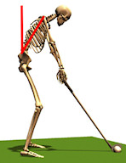
Why did Tiger Woods lose the 2009 PGA Championship? During the press conference directly after the loss, Tiger himself didn’t know why he lost; why is he was unable to execute those last two holes. He may never know the reasons but a pioneering technique of BioAcoustic Biology and vocal profiling may be able to reveal the answer.
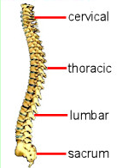
A Vocal Profile, which examines the infrasound and harmonic biomarkers of verbal communication, was performed which verified several issues that could have contributed to his less than stellar performance. Several vertebras that support a golf swing were identified as structural problem areas: Lumbar-1 showed to be weak while, Sacral-1, Thoracis T-6 and T-10 all showed to be over stressed. The Thoracic vertebrae allow for the rotation of the spine in the upper back; the sacral and lumbar regions act to limit rotation in the lower back. Tight muscles also contribute to potential injury of a muscle.
Experts agree that optimal positioning and mobility of the spine is a significant factor in the optimal and accurate performance of an accomplished golf swing. Woods’ training team would be wise to use stretching exercises to release the tight ankle, pectoral and deltoid muscles that were identified as being in stress. Specifics of his report are available from The Institute of BioAcoustic Biology – 740-698-9119.
Using the frequencies of the voice can often reveal information about a person’s structural or biochemical status when conventional medical care cannot determine the cause. Woods’ televised PGS press conference provided a fresh sample of Woods’ voice for evaluation. “The fresher the vocal print after an event the more accurate we can be” stated Sharry Edwards, the acknowledged pioneer of this novel technology.
Sound Health, the company that executed the analysis of Woods’ vocal frequencies is located in Albany, Ohio. It is the largest alternative health research facility in Ohio and has been recognized by Ohio’s BioOhio Technology Division as being among the most innovative biotech companies in Ohio. Edwards has received many awards for her work which has appeared in nearly 30 books, countless publications and more than a dozen documentaries. The company sponsors an on-line Journal that can be found at www.jbab.org. The most current issue features several articles dealing with joint pain alleviation and muscle mobility. The articles detail how sound waves have been successfully used to increase (or decrease if need be) muscle strength and action.
“The fresher the vocal print after an event the more accurate we can be”

http://www.med.nyu.edu/hjd/hjdspine/education/anatomy/bonesanddiscs/vertebrae.html
http://www.springerlink.com/content/q63lt4585142k120/
http://perfectgolfswingreview.net/weight.htm

NanoVoice software was used for this evaluation. NanoVoice is a Vocal Profiling personality survey developed by Sound Health and the Institute of BioAcoustic Biology. A complimentary copy of the software can be downloaded at nanoVoice.org
Tiger's apology
Recording Date: 02/28/2010
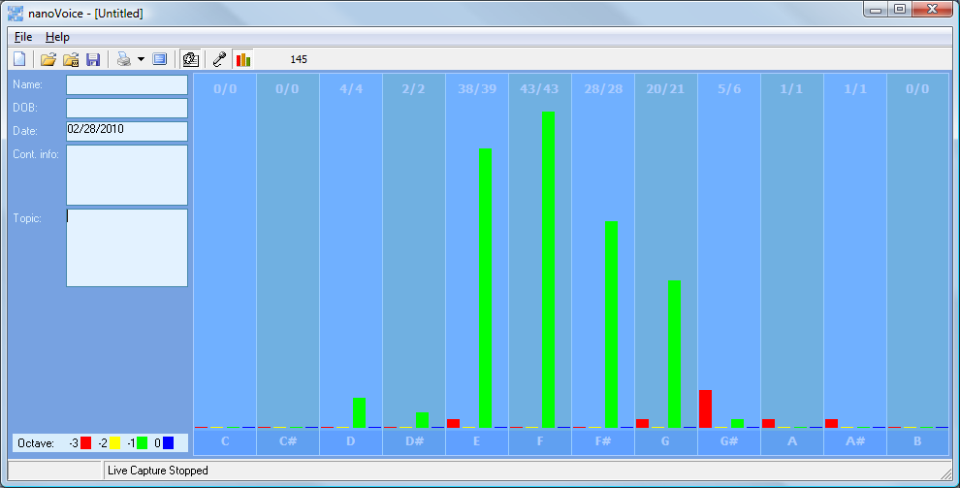
“My real apology to her will not come in the form of words. It will come from my behavior over time.”
Manual printout – this statement was uttered for a long term purpose that was planned and executed with a useful goal in mind. The planning and execution of that plan using words was for a specific purpose of safe-guarding some physical goal.
Computer print-out
Tiger apology
Recording Date: 02/28/2010
Subject/Topic: Tiger: “My real apology to her will not come in the form of words. It will come from my behavior over time.”
Missing Notes

You have no hits for the note(s) of: C, C#, B. Either you did not take enough samples (100-500 is usually best) or your subject matter did not include thoughts or topics that would involve this/these note(s). See the Note Correlate Chart that appears on the Cover Page for more explanation.
Points of Importance, Attention and Consequence
Your highest note is associated with the integration of appropriate perception and action. The ability to assess a situation quickly resides with this note. Your highest note deals with expression through words both written and oral. The world of creative self-expression resides with this note. Your highest note is associated with the expression of duty to work and accomplishment. The ability to see the flaws in a plan and make it right resides with this note.
Being able to prioritize what needs to be done emotionally is not always easy for you. You may be caught once in a situation but you aren't often caught twice without a proper answer.
You do what you do for the benefit of all concerned, even if it stresses you personally. You wish for the best which sometimes leads to statements of hope instead of statements of fact.

Tiger apology to friends
Recording Date: 02/28/2010
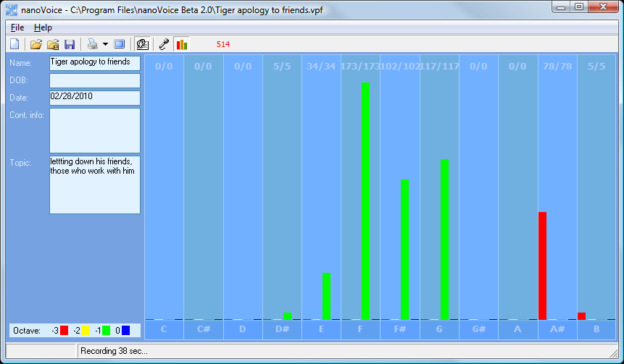
Subject/Topic: letting down his friends, those who work with him
Manual print out – some of this apology was spontaneous (A#) and spiritually felt in the moment. This was more planned than the apology to his wife but not as constructed. He doesn’t want to talk about this, just go through the motions and get it done because there is the future to think about.
Computer print out
Your highest note is associated with the integration of appropriate perception and action. The ability to assess a situation quickly resides with this note. Your highest note is associated with the expression of what you consider to be your physical domain. Having dominion over your physical environment resides with this note. Your highest note is associated with the expression of duty to work and accomplishment. The ability to see the flaws in a plan and make it right resides with this note.
You may be caught once in a situation but you aren't often caught twice without a proper answer. Those around you will allow you to give too much unless you define your own needs. You tend to do more for others than they do for you. The right words at the right time can sometimes elude you because of all of the internal dialogue.
You wish for the best which sometimes leads to statements of hope instead of statements of fact. Your connection to universal truths demands your time. You wish someone could understand you without demanding a lot of conversation.

Tiger-bitterly disappointed
Recording Date: 02/28/2010
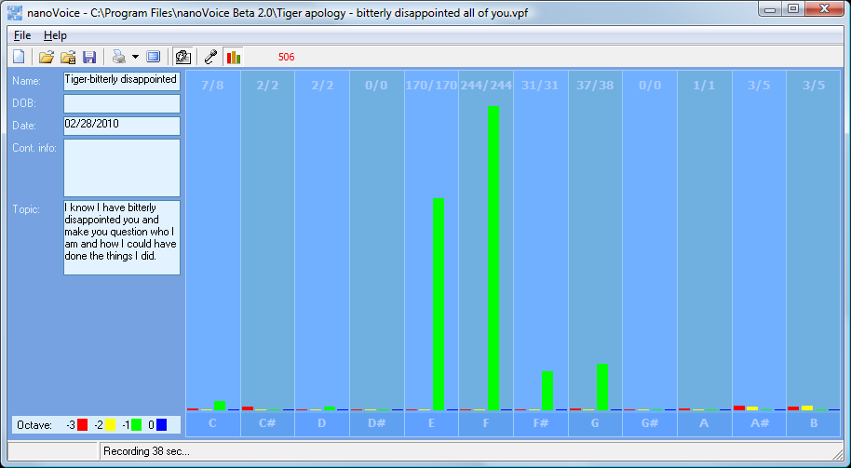
Subject/Topic: I know I have bitterly disappointed you and make you question who I am and how I could have done the things I did.
Manual: more of the same – use words for a future goal or purpose
Computer print-out
It is easy for you to see the faults in others but don't always know how to get your point across politely. If you ever had to lie to see justice done, you would do it but your sense of justice does not always jive with the law. Your stamina to get things accomplished is admirable.
Your highest note is associated with the integration of appropriate perception and action. The ability to assess a situation quickly resides with this note. Your highest note deals with expression through words both written and oral. The world of creative self-expression resides with this note. Your highest note is associated with the expression of what you consider to be your physical domain. Having dominion over your physical environment resides with this note.
Being able to prioritize what needs to be done emotionally is not always easy for you. Your metabolism shows be a weak point in your vocal print. You don't always express your sense of confusion to the appropriate person. You can sometimes do too much for others in the hopes of helping them change.

You would like to have more time to spend on spiritual things. You have a hard time prioritizing what you want to do first. It is hard for you to understand why people take your peaceful nature as being an easy target. You can be very hard on yourself - taking blame or responsibility needlessly.

Tiger - I am so sorry
Recording Date: 02/28/2010
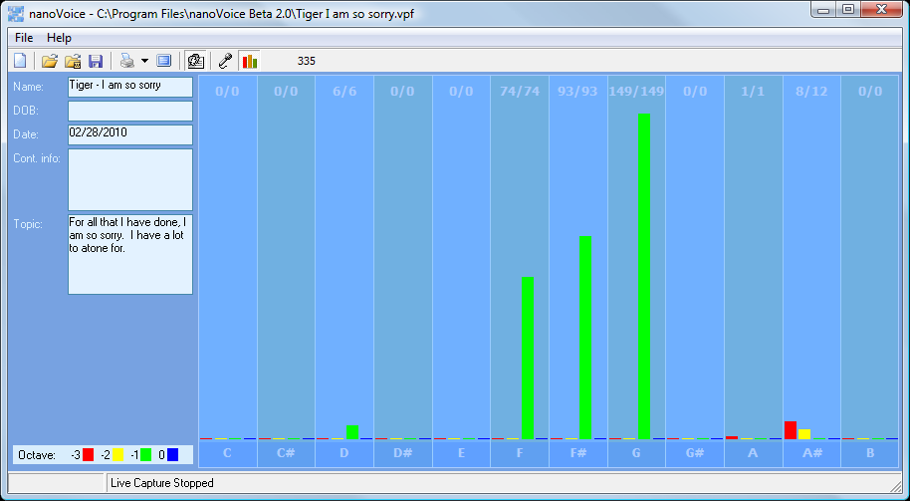
Subject/Topic: For all that I have done, I am so sorry. I have a lot to atone for.
Manual: This statement was planned and orchestrated to carry out a physical goal.
Your highest note is associated with the expression of what you consider to be your physical domain. Having dominion over your physical environment resides with this note. Your highest note is associated with the expression of duty to work and accomplishment. The ability to see the flaws in a plan and make it right resides with this note. Your highest note is associated with the integration of appropriate perception and action. The ability to assess a situation quickly resides with this note.

Tiger about abuse from wife
Recording Date: 02/28/2010
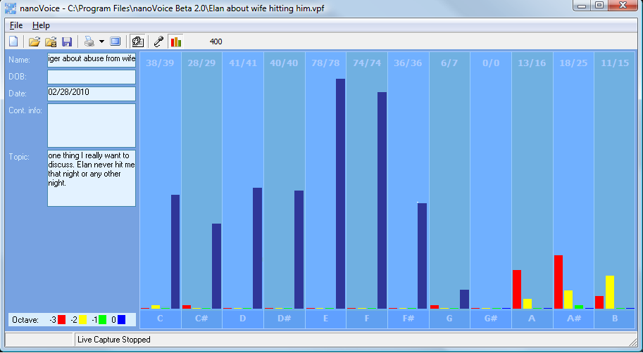
Subject/Topic: one thing I really want to discuss. Elin never hit me that night or any other night.
Manual: his emotion is about his wife’s reputation. He is highly emotional about people thinking his wife did anything to him. He is protecting her, feels this is his duty. Feels responsible that anyone would think that he perpetuated his wife in this light.
Your highest note is associated with the expression of Self Approval and Self Worth. Issues of digestion, enzyme and energy production reside with this note.
Structure is not required for you to be comfortable. Those around you will allow you to give too much unless you define your own needs. You tend to do more for others than they do for you. Being able to prioritize what needs to be done emotionally is not always easy for you. Your metabolism shows be a weak point in your vocal print.
Composite below shows that the general thrust of his speech was emotional. It was hard on him to do this. Two intentions show up: to protect the future of something physical that deals with his friends, his fans and those he works with AND to emotionally protect his wife’s reputation. It is important to him that his physical environment remains useful. There is some high spiritual energy going on here. He seems genuine that he wants to preserve his future and he is now engaging his emotions to see that is goal becomes a reality. Maybe he has finally realized that although the rich and famous get away with playing with different rules, those people around him will not tolerate that behavior.
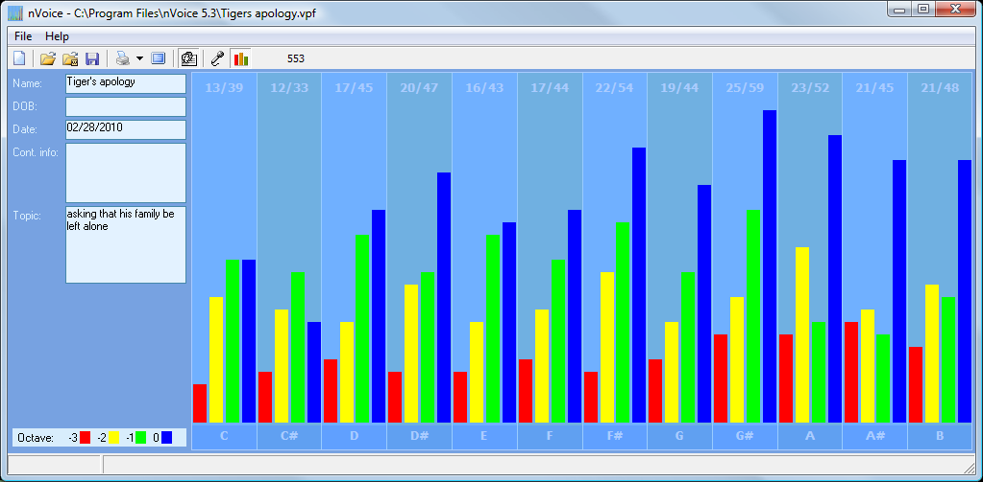
Subject/Topic: asking that his family be left alone
Points of Importance, Attention and Consequence
You want everything done but you do so much that some things don't get done on time. You can be fussy about your physical space. It needs to satisfy you and no one else. Sometimes you spend a lot of energy trying to get even the smallest detail right the first time. You have an unusual sense of time. Not having all the information needed to make a decision stresses you. Your reputation is very important to you. You will go to great lengths to protect it. You push yourself and others to finish the job. You love new ideas that mean you can have a project to work on. A sense of belonging is important to you Your highest note is associated with the expression of physically prioritizing what you need and want to accomplishment. Personal control over what happens in your physical environment resides with this note. Your highest note is associated with the expression of your internal perspective of insight and self awareness. Internal faith, fairness and fulfillment reside with this note. Your highest note is associated with the expression of duty to work and accomplishment. The ability to see the flaws in a plan and make it right resides with this note
You sometimes depend on others to support your place in the world. You can see how a situation needs to play out but you don't want to seem interfering. You don't always express your sense of confusion to the appropriate person when others attempt to deal with you inappropriately. Sometimes you think you might as well be invisible when you spend your energy to help others because they don’t seem to be listening at the moment. You want to do something about the mess the world is in but just don't seem to have the energy. Your leadership ability is hampered by lack of opportunity. The right words at the right time can sometimes elude you because of all of the internal dialogue. You would rather not talk than say something useless

Points of Communication, Complications and Complaints
You have the ability to organize and prioritize in your head. It may not look that way to others but it is your mode of operation. You like to organize yourself so that everything is at hand and easy to utilize. It is particularly bothersome when people use or borrow your property without permission.
You are capable of pushing yourself to get things done. Creating new projects from the ideas you generate is rewarding. You take pleasure in changing things for the better.
Seeing every side of an issue is important to making the right decision that is for the betterment of all concerned. You can easily put yourself aside for the benefit of others. You can be good counsel for others if you allow them to keep their own systems intact and not insist they follow yours.
You don't always know how to fight back to secure what is properly your due. It is hard for you to understand why people take your peaceful nature as being an easy target. As long as a rule doesn't pertain to you or yours personally, you don't often bother to object. You very much appreciate those who come to your verbal rescue.
You like to contemplate an issue before you speak up. You are sometimes reluctant to take the lead. You have good ideas but are sometimes reluctant to speak up. You like the idea of leadership but sometimes take on more than you expected to contribute.
You like praise but don't always know how to accept it humbly. You don't always know what words to use to express what your real needs are. You would rather they just be provided. You wish someone could understand you without demanding a lot of conversation.
Points of Cooperation, Learning, Opportunity and Growth
You dislike being accused of something you did not do because it hurts your spirit. When you are satisfied with your decision, you no longer need to talk about it. You have the ability to influence others from a spiritual perspective.
You have the ability to perceive what others may be thinking and can use it to your benefit. Your verbal skills make you a good trainer. You have the ability to play word games. You would make a good mediator.
You like reciprocal relationships but often give more than you receive. You can be incredibly generous if your generosity is appreciated. You give of your time and organizational skills easily for a good cause.
You have a natural knack for planning. You like helping others do for themselves. Working for a cause usually puts you out front because of your organizational skills.

You are willing to spend a lot of your time making sure that others learn about integrity, wisdom and responsibility. You challenge yourself much more than others challenge you. You love seeing all the pieces fall together to make it all work.
Getting to the core of what you really believe to be the right way of life is important to you. There are times when you disregard your own needs in order to help others. It is important to you that you make a difference in the lives of others. To help them move toward a more unselfish life. You are a natural teacher by example. You have a patient outlook on life and can work toward a specific goal without regard for your own needs.
You can use words to help others find their path. You can go to a deep internal space using self dialogue. You can talk others into carrying out the details. You can envision an end result but don't want to be required to explain everything in detail.
You work to see that others are not taken advantage of. Writing that flows freely to you can also help move others towards their own inner strength. Your self approval depends on living from the inside out - from the core of your being. You have a great ability to learn from your own mistakes and move on.
Spiritual laws and what's RIGHT is more important than Man's laws. Protecting people's feelings is very important to you. You ability to help others through emotional turmoil is admirable.
You like to get things done but need a plan first. You don't like people interfering with the way things need to get done. You don't mind helping but you don't what to be kept to a schedule or plan that is not your own.
You have a tendency to think you ought to fight authority to prove personal points of honor even when it costs you. Joining a group that thinks like you do will help bring justice to a situation. Your own self approval issues can get in the way of expressing your opinions that need to be heard. You can be quick to judge before you gather all the pertinent facts. In most cases it is a lack of understanding your motivations.
You have good intention about bringing your plans to fruition. You seem disorganized to the casual onlooker. You would like more options about your physical surroundings.
Being aware of how others will take what you say is of concern to you. You have a knack for teaching by demonstration. You can easily take charge of a physical situation using words.
You have the ability to go deep within to find answers about your direction in life. Being perceived as a solid and resourceful person is important to you. You strive to balance what others want from you with what you know to be your destiny.
Your stamina to get things done is admirable. Others see you as a balanced and busy person. Your motivation sets a good example.

You can get involved quickly without knowing all the facts when you perceive an injustice. Those around you attempt to influence you through your emotions. When you think what has happened is unfair, your first thought is to make things right. You do this without thinking about how your actions will be perceived.
There are indications that issues with cellular oxygenation may need monitoring. Identifying which foods are most compatible with you is important to your digestive health. The process of digestion needs to be considered via enzyme evaluation.

